Ye,Zhengkun

Java project 5

03/27/14

**import** java.util.Scanner;

**public** **class** ScanningText {

Scanner strScan;

**char** ch;

String word, longWord;

**int** charAmt, digAmt;

**int** charFreq[];

**private** String user_entry; {

// count letters

charAmt = 0;

digAmt = 0;

**for**( **int** i = 0; i < user_entry.length( ); i++ ){

ch = user_entry.charAt(i);

**if**(Character.*isAlphabetic*(ch)){

charAmt++;

}

**if**(Character.*isDigit*(ch)){

digAmt++;

}

}

// find longest word

strScan = **new** Scanner(user_entry);

longWord = "";

**while**(strScan.hasNext()){

word = strScan.next();

ch = word.charAt(word.length() - 1);

// check for punct.

**while**(!Character.*isAlphabetic*(ch)){

word = word.substring(0, word.length() - 1);

ch = word.charAt(word.length() - 1);

}

// compare vs longest

**if**(word.length() > longWord.length())

longWord = word;

}

System.*out*.println("longest word: " + longWord + " has " + longWord.length() + " letters.");

// array to record counts

charFreq = **new** **int**[26];

**for**(**int** i = 0; i < 26; i++) charFreq[i] = 0;

// update counts

**for**(**int** j = 0; j < user_entry.length(); j++){

ch = user_entry.charAt(j);

**if**(Character.*isAlphabetic*(ch)){

ch = Character.*toUpperCase*(ch);

charFreq[ch - 'A']++;

}

}

// print freq

**for**(**int** k = 0; k < 26; k++){

**if**(charFreq[k] != 0)

System.*out*.println( (**char**)('A' + k) + " -- " + charFreq[k]);

}

}}

**import** java.util.Scanner;

**public** **class** BinaryConversion {

**public** **static** **void** main(String[] args) {

Scanner input = **new** Scanner(System.*in*);

String binary;

binary = " ";

System.*out*.print("Enter a binary number: ");

binary = input.nextLine();

**while** (!binary.equals("-1") && *checkifbinary*(binary)){

System.*out*.println("Conversion to Decimal:" + *decimal_num*(binary));

System.*out*.print("Enter a binary number: ");

binary = input.nextLine();

}

}

**public** **static** **boolean** checkifbinary(String binary){

**boolean** yesorno;

yesorno = **true**;

**for**( **int** i = 0; i < binary.length( ); i++ ){

**if**(Character.*isLetter*(binary.charAt(i))) yesorno = **false**;

}

**return** yesorno;

}

**public** **static** **int** decimal_num (String binary){

**int** num_digits, decimal_num, y;

decimal_num = 0;

String[] total_digits = binary.split("");

num_digits = (total_digits.length)-1;

y = num_digits;

**for**(**int** i=1; i <= y ; i++){

**int** digit, x;

digit = Integer.*parseInt*(total_digits[i]);

x = digit * (**int**)Math.*pow*(2,num_digits-1);

decimal_num = decimal_num + x;

num_digits = num_digits -1;

}

**return** decimal_num;

} {System.*out*.print("All set! ");

}}

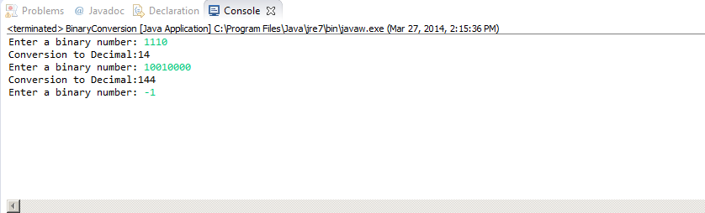

I only save these two in my iphone this time. I will turn it in next class. ( Finished items)